

Submitted by : Spogmai Jan
Roll no : 2430 -0081
Submitted to : sir nouman asim

Computer networks lab

Tasks 1: • Establish the Connection between Two system configuring them with different Ip addresses. PC1 IP address 192.168.1.1 and PC2 IP address 192.168.1.2. Then check whether the Connection is established Between systems or not.

IP address of PC-0 :

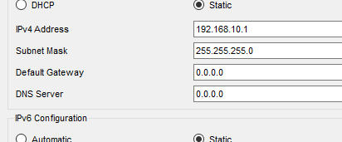

IP address of PC-1:

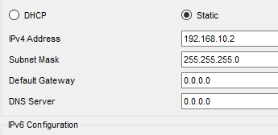

Connection between two systems :
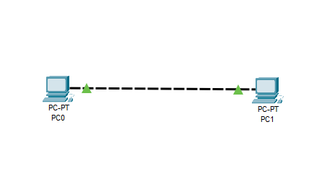

Tasks 2: • Make a network having 5 pc’s. Used one Hub. Establish the Communication Between Systems.
IP address of PC-0 :

IP address of PC-1:

IP address of PC-2 :

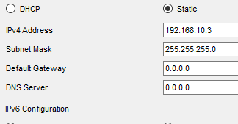
IP address of PC-3 :

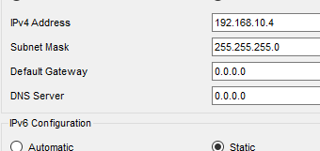
IP address of PC-4 :

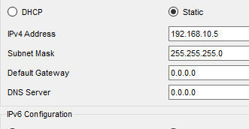

Communication between systems using one hub :
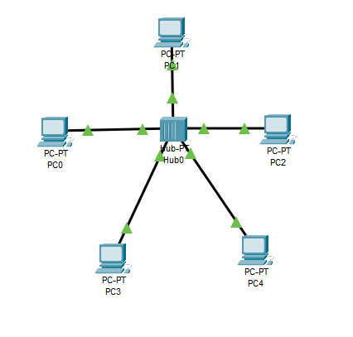

Tasks 3: • Make a network having 6 pc’s. Used one Hub. Establish the Communication Between Systems. In Simulation send the packet PC0 to PC4.

Network of 6PCS and one hub:
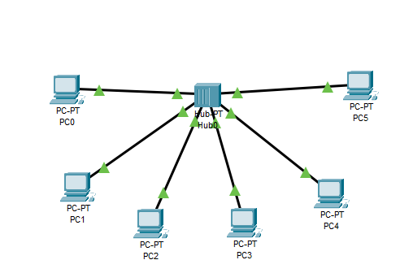

Sending the packet PC-0 to PC-4:
Using ping command:
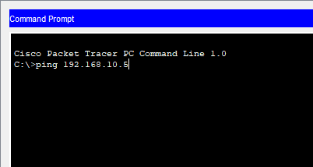

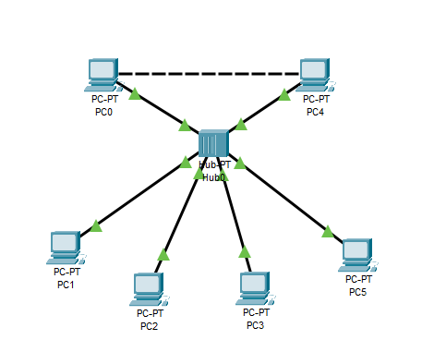

Task :04
• Make a network having 6 pc’s. Use 2 switches and one router for communication. Default Gateway with Switch1 is (10.0.0.4) and Switch2 is (192.168.1.4). • Send message from LAN1 Pc1 t0 LAN2 Pc2 in Simulation and Check wheather the message is Deliver or Not.

Default gateway with switch 1:
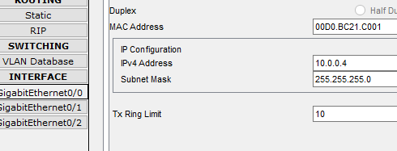

Default gateway with switch 2:
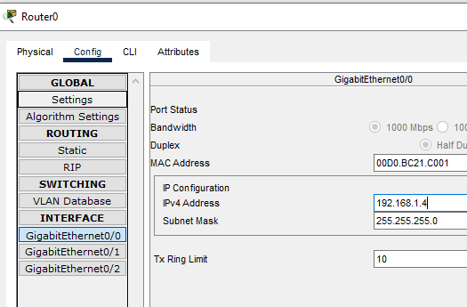

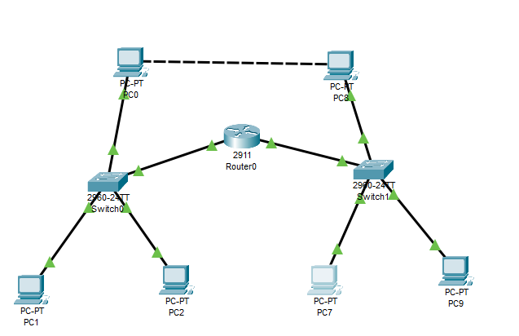
Tasks 5:• Make a network having 8 pc’s. Use 2 switches and 1 router for communication.
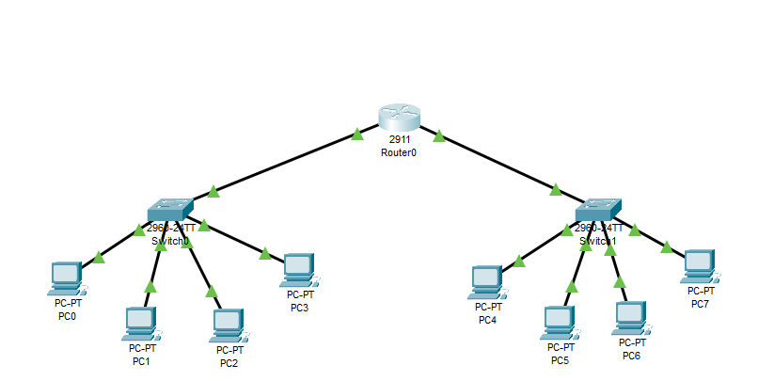
Make a network having 9 pc’s . Use three switches and 1 router for communication.

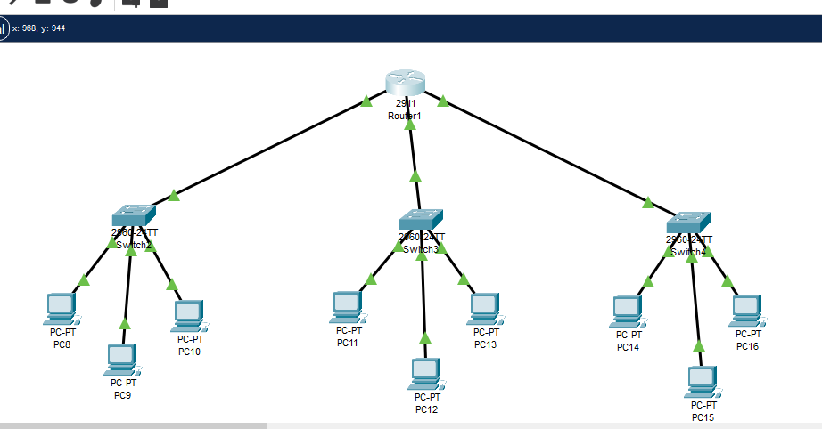

Send message from Pc3 t0 Pc6 in Simulation and Check wheather the message is Deliver or Not.




